**Project Design Phase-II Data Flow Diagram & User Stories**

|  |  |
| --- | --- |
| Date: | 03 October 2022 |
| Team ID: | PNT2022TMID50978 |
| Project Name: | Nutrition Assistant Application |
| Team Leader:  Team members: | M.Abinaya  J.Gayathri R.Vaitheeswari J.Chitra |

**Data Flow Diagrams:**

A Data Flow Diagram (DFD) is a traditional visual representation of the information flows within a system. A neat and clear DFD can depict the rightamount of the system requirement graphically. It shows how data enters and leaves the system, what changes the information, and where data is stored.

Example: DFD Level 0

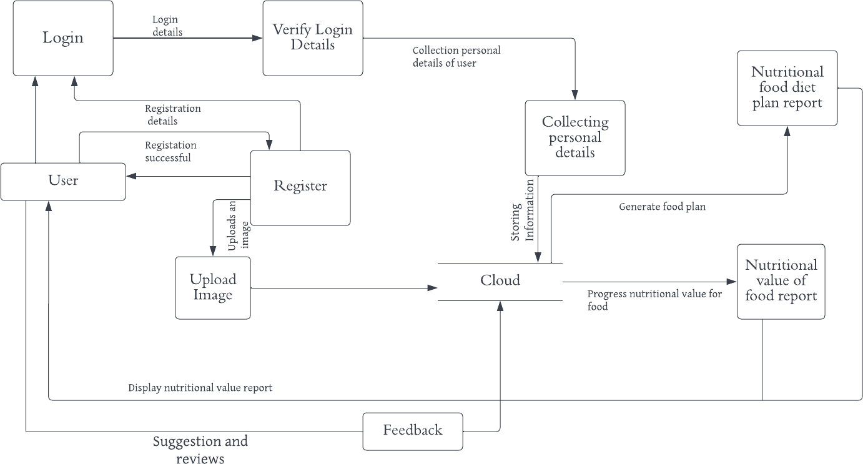

**User Stories:**

|  |  |  |  |  |  |  |
| --- | --- | --- | --- | --- | --- | --- |
| **User Type** | **Functional Requirement (Epic)** | **User Story Number** | **User Story / Task** | **Acceptance criteria** | **Priority** | **Release** |
| Customer (Mobile  user) | Registration | USN-1 | As a user, I can register for the application by entering myemail, password, and  confirming my password. | I can access my account / dashboard | High | Sprint- 1 |
|  |  | USN-2 | As a user, I will receive confirmation email once I haveregistered for the  application | I can receive confirmationemail  & click confirm | High | Sprint- 1 |
|  | Login | USN-3 | As a user, I can log into the application by entering email & password | I can login when passwordand email  are correct | High | Sprint- 1 |
|  | Collecting personal  details | USN-4 | As a user, I can provide a personal information for processing | I can enter the personaldetails | Mediu m | Sprint- 1 |
|  | Upload image | USN-5 | As a user, I can upload an image for the  processing of food. | I can upload a food  image. | High | Sprint-  1 |
|  | Feedback | USN-6 | As a user, I can give feedback | I can give feedback aboutthe  application | Low | Sprint- 1 |
| Cloud | Nutritional  value of report | USN-7 | In cloud the food image is processed and  provides thenutritional value of food. | It gives the  nutritional value | High | Sprint-  2 |

|  |  |  |  |  |  |  |
| --- | --- | --- | --- | --- | --- | --- |
|  |  |  |  | of food. |  |  |
|  | Nutritional food dietplan report | USN-8 | In cloud the food diet plan based on nutritional value is  generated based on the personal  information provided by the user. | It provides the dietnutritional plan. | Mediu m | Sprint- 2 |